CS-114 - Fundamental of Programing

Assignment # 1

**Course Instructor:** Dr Khwaja Fahad Iqbal

**Lab Instructor:** Muhammad Affan

## Student Name: Muhammad Hanzla Masood

**CMS ID: 463722**

**DATE:**

**2nd October, 2023**

**Task 1:**

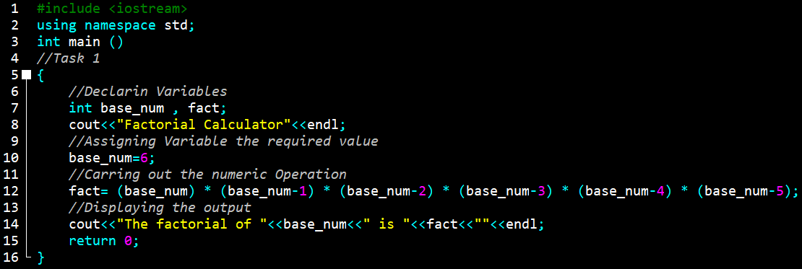

**Task 1 Output:**

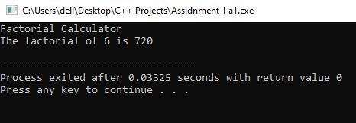

**Task 2:**

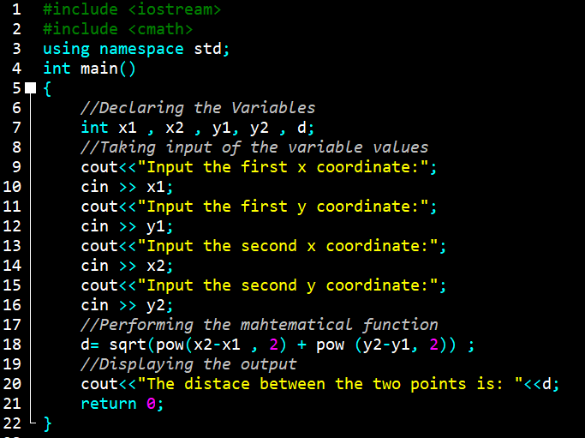

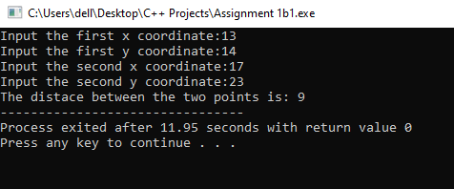**Task 2 Output:**

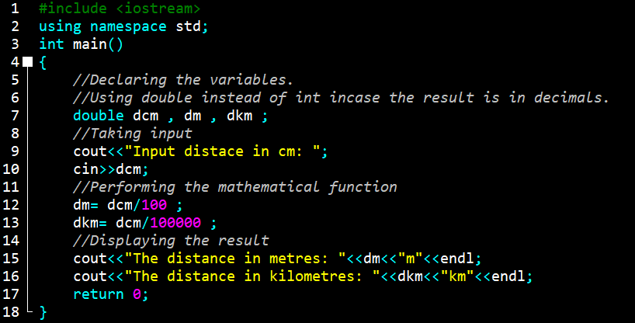**Task 3:**

**Task 3 Output:**

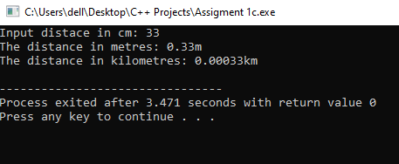

**Task 4:**

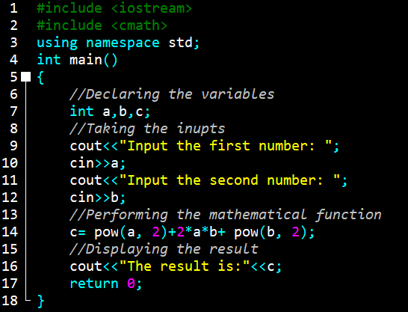

**Task 4 Output:**

